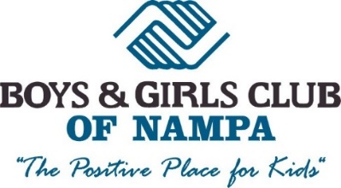

Position Title: Youth Development Professional (YDP)
Part-Time Position: M-F, 29hrs a week (5.5hrs/ day) between 7am – 6:30pm
Full-Time Position: M-F, 40hrs a week (8hrs/ day) between 7am-6:30pm
Salary: $8.50 - $9/hr.

Job Duties
Engage and inspire young people aged 6 – 12 to learn and grow to be responsible adults. Oversee the core programs of the Club by planning, developing and implementing programs and activities that support the organizations standards. Must monitor and evaluate situations quickly using good judgements to assess situations and make decisions. Create and maintain a safe environment for members and adults within the program space. Communicate with parents as necessary regarding behavior issues and Club events.

Qualifications
- Experience working with children
- Patience and understanding for youth
- Ability to plan and implement quality programs for youth
- Valid state driver’s license
- Positive and energetic attitude!

COVID-19 Policies
Staff are required to wear a mask and gloves at all times and practice social distancing with themselves and the club members. A full-time janitor will be on site disinfecting the facility throughout the day. All COVID-19 recommendations will come through Southwest District Health, St. Luke’s, St. Al’s, and other local health professionals.

Please e-mail acalloway@bgclubnampa.org with resumes or stop by 316 Stampede Drive Nampa, ID 83687 with your application. Feel free to call us at (208) 461 – 7203 with any questions regarding this position.

